# Metaflow HW

## Pre-requisites

Python version - Python 3.7.7

Packages - requirements.txt

## Data Used to Initialize Key-Value store

<https://raw.githubusercontent.com/savingoyal/systems-assignment/main/example.data>

Read directly from URL

## Results

### Server

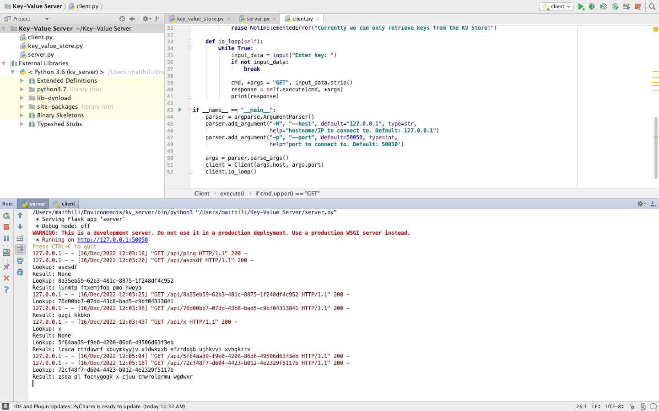

### Client

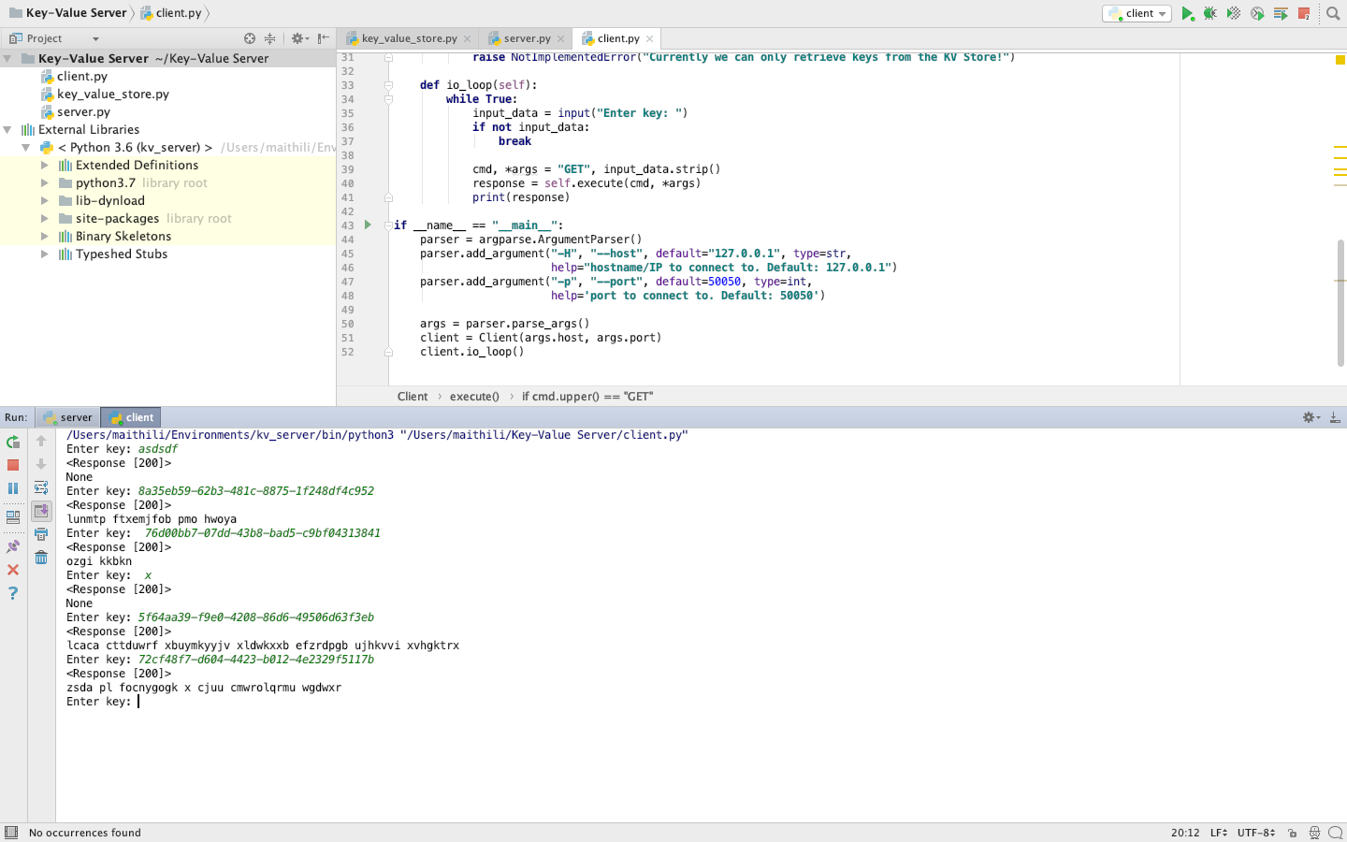

## REST APIs implemented

/api/ping GET

/api/<key> GET